Data QUERY Languages (DQL)
1.Project categories_name from categories
Query:
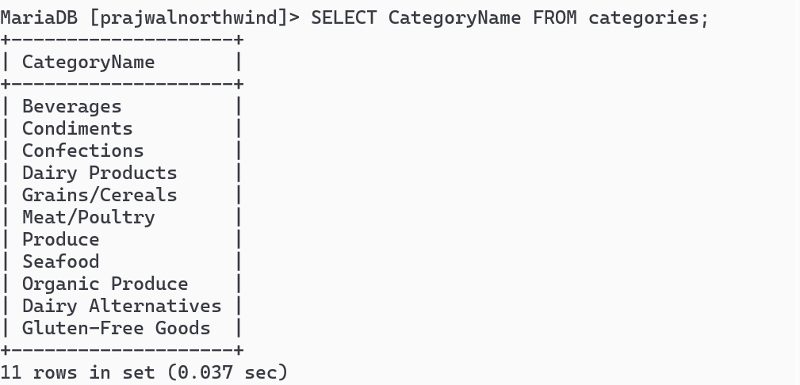
- Project country from customers:
Query:
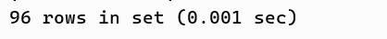

- Project city, country from customers:
Query:
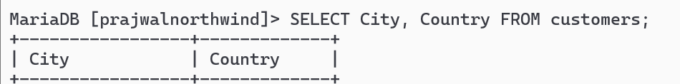

- SELECT CustomerName from customers who are from Madrid City Query:
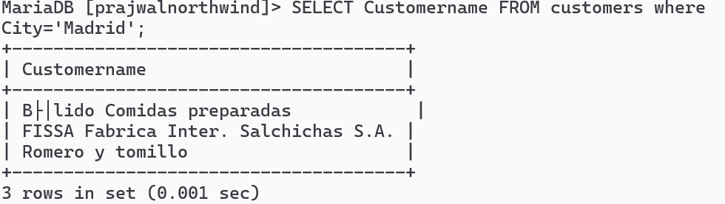
- SELECT CustomerID from customers who are from Germany
Query:

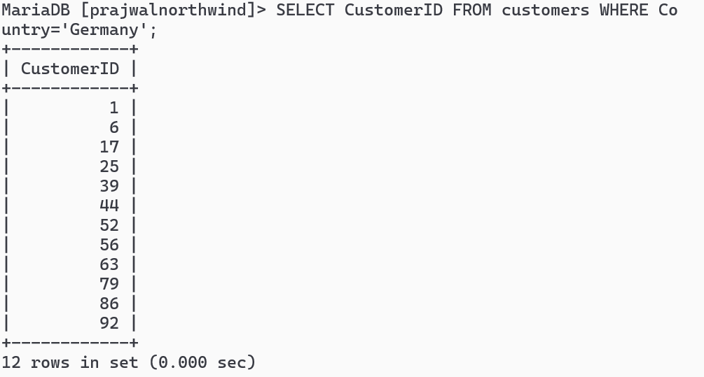
- SELECT CustomerID, CustomerName from customers who are from Germany or Spain:
Query:

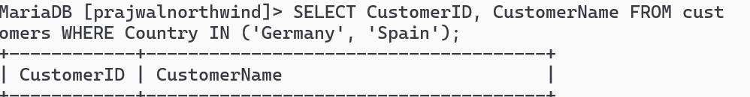
- SELECT all from customers who are from London and UK:
Query:
- SELECT all from customers who are from city having names that start with first letter of Your Name.
Query:

- SELECT all from customers who are not from Canada and Belgium
Query:
10.SELECT all from customers who are from G7 Countries
Query:

11.SELECT all from customers who have PostalCode containing 31:
Query:

12.SELECT all from customers having PostalCode containing 00 and from Rome or Paris.
Query:

13.SELECT all from customers who are not from Salzburg
Query:

14.SELECT all employees who are born on July:
Query:

15.SELECT all employees having BA degree in Notes:
Query:

16.SELECT all suppliers from USA and Japan
Query:

17.Find name and count of suppliers from different countries.
Query:

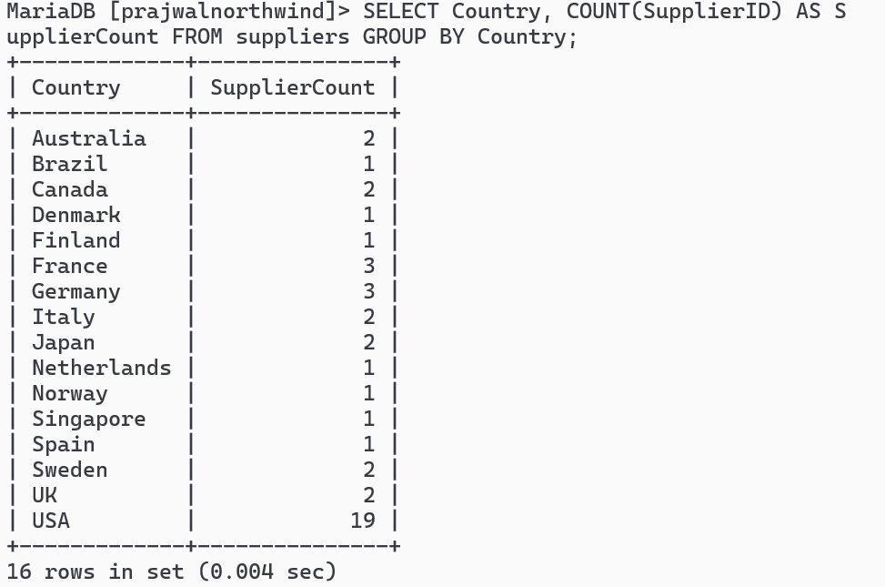
18.Find name and count of customers from different cities.
Query:

19.Find number of orders made by employee along with employeeID. Query:

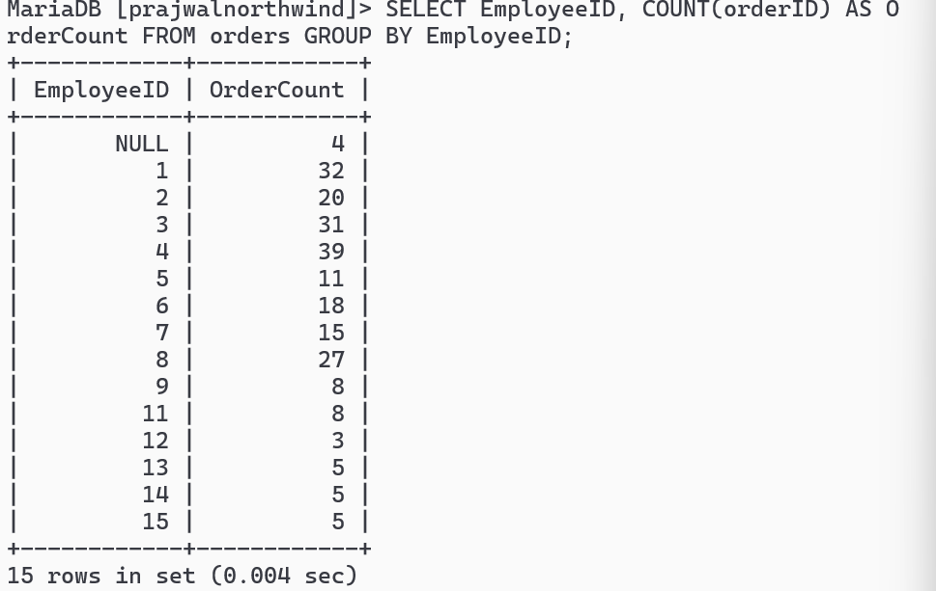

20.Find number of orders made by customers along with customerID: Query:

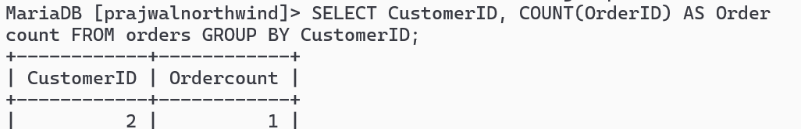
21.Find all order that are shipped by shippers having 1 or 3 shipperID Query:

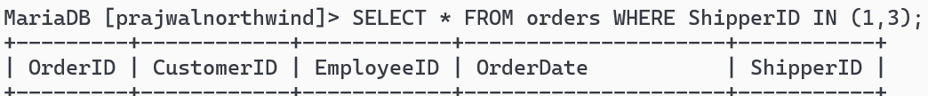
22.SELECT all product having categoriesID 1.
Query:

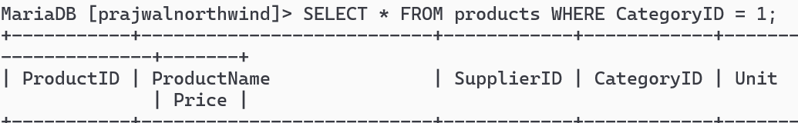
23.SELECT all products having ProductName that starts with First Letter of your name.
Query:

